LECTURE-7
ASYMMETRIC CRYPTOGRAPHY THEORY

Introduction to Asymmetric Cryptography
Public Key
- A key that is openly available to everyone
- Used for:
  - Encrypting messages
  - Verifying digital signatures
Private Key
- A key that is kept secret by the owner
- Used for:
  - Decrypting messages
  - Creating digital signatures
Key Idea
- Public key is used to encrypt
- Private key is used to decrypt
Example
- Alice shares her public key
- Bob encrypts a message using Alice’s public key
- Only Alice can decrypt it using her private key
Difference Between Symmetric and Asymmetric Cryptography
Feature | Symmetric Cryptography | Asymmetric Cryptography
Number of keys | One shared key | Two keys (public and private)
Key distribution | Difficult | Easier
Speed | Fast | Slow
Security | Depends on secrecy of shared key | More secure for communication setup
Example use | Data encryption | Key exchange, digital signatures
Key Point
- Asymmetric cryptography is slower but solves the key distribution problem.
Why Asymmetric Cryptography Was Needed
Problems with Symmetric Cryptography
- Secure key distribution is difficult
- Requires a trusted third party
- If the key is exposed, communication is compromised
- No protection against sender forgery
Solution Provided by Asymmetric Cryptography
- Eliminates need for secure key sharing
- Enables secure communication between unknown parties
- Supports authentication and digital signatures
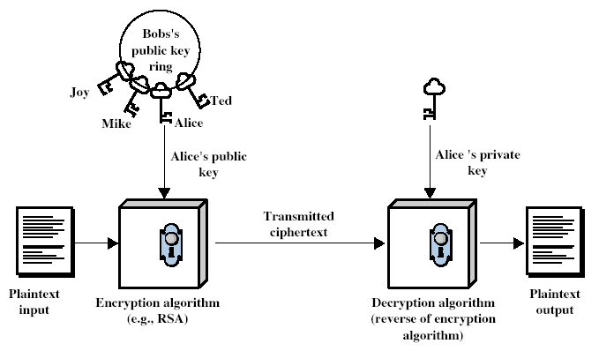
Advantages and Limitations
Advantages
- Solves key distribution problem
- Provides authentication (digital signatures)
- Supports secure communication over insecure channels
Limitations
- Slower than symmetric cryptography
- Requires large key sizes
- Not efficient for encrypting large data
Important Point
- Asymmetric cryptography does not replace symmetric cryptography
- It is used together with symmetric cryptography

Characteristics of Public-Key Cryptosystems
Two-Key System
- Uses a pair of keys:
  - Public key (shared)
  - Private key (secret)
- Keys are mathematically related
One-Way Functions
Definition
- Functions that are:
  - Easy to compute in one direction
  - Extremely difficult to reverse
Examples
- Multiplication vs factorization
- Exponentiation vs discrete logarithm
Security Basis
Concept
- Security depends on computational difficulty
Key Idea
- Even if algorithm and public key are known:
  - It is infeasible to compute private key
Important Point
- Security relies on:
  - Large key sizes
  - Hard mathematical problems
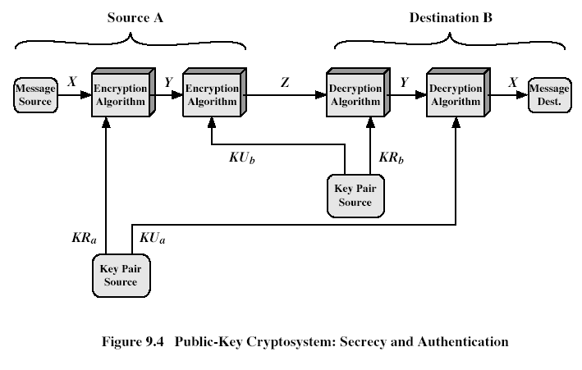
Complete Flow (Secrecy + Authentication)
At Source A
Step 1: Message Generation
- Message source produces plaintext X
Step 2: First Encryption (Authentication)
- X is given to Encryption Algorithm
- Uses KRₐ (private key of A)
- Output becomes Y
Operation:
- Y = E(KRₐ, X)
Meaning:
- Message is signed (authentication)
Step 3: Second Encryption (Secrecy)
- Y is given to next Encryption Algorithm
- Uses KU_b (public key of B)
- Output becomes Z
Operation:
- Z = E(KU_b, Y)
Meaning:
- Message is now encrypted for confidentiality
Step 4: Transmission
- Z is transmitted over channel
At Destination B
Step 5: First Decryption (Secrecy)
- Z is given to Decryption Algorithm
- Uses KR_b (private key of B)
- Output becomes Y
Operation:
- Y = D(KR_b, Z)
Meaning:
- Removes outer encryption (confidentiality layer)
Step 6: Second Decryption (Authentication)
- Y is given to next Decryption Algorithm
- Uses KUₐ (public key of A)
- Output becomes X
Operation:
- X = D(KUₐ, Y)
Meaning:
- Verifies sender and recovers original message
Step 7: Message Delivered
- X is received at Message Destination

Applications of Public Key Cryptography
Key Distribution
- Used to securely exchange keys
- Example: Diffie-Hellman
Digital Signatures
Purpose
- Verify identity of sender
- Ensure message integrity
Working
- Sender signs message using private key
- Receiver verifies using public key
Confidentiality (Encryption/Decryption)
Process
- Sender encrypts using receiver’s public key
- Receiver decrypts using private key
Result
- Only intended receiver can read the message

Hard Mathematical Problems in Cryptography
Factorization Problem
Definition
- The problem of breaking a number into its prime factors
- Example:
  - 91 = 7 × 13
Key Idea
- Multiplying primes is easy
- Finding the primes from a large number is very difficult
Importance in Cryptography
- Used in algorithms like RSA
- Security depends on the difficulty of factoring large numbers
Exam Point
- “Factorization is computationally hard for large integers, forming the basis of RSA security.”
Discrete Logarithm Problem
Definition
- Given:
bᵏ ≡ g (mod n)
- Find the value of k
Example
- 3ᵏ ≡ 13 (mod 17)
- Solution: k = 4
Key Idea
- Exponentiation is easy
- Finding exponent (log) is difficult
Importance
- Used in:
  - Diffie-Hellman
  - ElGamal

Discrete Logarithm Concept
Definition
- A discrete logarithm is the exponent k such that:
bᵏ ≡ g (mod n)
Why It Is Computationally Hard
Reasons:
- No efficient general algorithm exists
- Requires checking many possibilities (trial method)
- Complexity increases rapidly with large numbers
- Works in modular arithmetic, not normal numbers
Key Insight
- Easy: Compute bᵏ mod n
- Hard: Given result, find k
Exam Line
- “Discrete logarithm is a one-way function: easy to compute but hard to reverse.”

Primitive Roots
Definition
- A number b is a primitive root of prime p if:
its powers generate all numbers from 1 to p−1 (mod p)
Examples
Example 1:
For p = 7
- Powers of 3:
3¹ = 3
3² = 2
3³ = 6
3⁴ = 4
3⁵ = 5
3⁶ = 1
- Covers all values {1,2,3,4,5,6}
→ So, 3 is a primitive root of 7
Example 2:
For p = 7
- Powers of 2:
2¹ = 2
2² = 4
2³ = 1 (repeats)
- Missing values → Not primitive root
Properties
1. Cycle Length
- If b is a primitive root of prime p:
  - Cycle length = p − 1
2. Full Coverage
- Generates all non-zero residues mod p
3. Existence
- For every prime p, at least one primitive root exists
4. Repetition
- Powers repeat after p−1 steps
Exam Key Line
- “A primitive root modulo p generates all non-zero residues modulo p.”

Diffie-Hellman Key Exchange
Concept
Purpose
- Used for secure key exchange between two parties
- Allows both parties to generate a common secret key
Important Point
- It is not used for direct encryption of messages
- Only used to establish a shared key, which is later used in symmetric encryption
Algorithm Steps
Step 1: Public Parameters
- Both parties agree on:
  - q = large prime number
  - a = primitive root of q
These values are public
Step 2: Private Keys
- Each party selects a secret value:
  - xA = private key of A
  - xB = private key of B
These are kept secret
Step 3: Public Keys
- Each party computes their public key:
- yA = a^xA mod q
- yB = a^xB mod q
- These values are exchanged publicly
Step 4: Shared Key Generation
- Each party computes the same shared key:
- KAB = (yB)^xA mod q
- KAB = (yA)^xB mod q
Final Result
- Both parties get the same shared key KAB
Mathematical Formulas
Public Key Calculation
$$y_{A}=a^{x_{A}} mod q$$
Shared Key Calculation
$$K_{AB}=y_{B}^{x_{A}} mod q$$
Security Basis
Based On:
- Discrete Logarithm Problem
Key Idea:
- Easy to compute:
  - $a^{x}mod q$
- Very difficult to find:
  - x from $a^{x}mod q$
Result:
- Even if attacker knows:
  - q, a, yA, yB
- Cannot compute shared key easily
Limitations
Man-in-the-Middle Attack
Problem:
- No authentication mechanism
What happens:
- Attacker intercepts public keys
- Establishes separate keys with both parties
- Can read and modify communication
Key Point:
- Diffie-Hellman alone is not secure against MITM attack

Man-in-the-Middle (MITM) Attack
1. Concept
Definition
- A Man-in-the-Middle (MITM) attack occurs when an attacker secretly intercepts and possibly alters communication between two parties.
Key Idea
- The attacker places himself between sender and receiver
- Both parties think they are communicating directly with each other
Result
- Attacker can:
  - Read messages
  - Modify messages
  - Forward altered messages
2. Steps of Attack (Based on Diffie-Hellman)
Step 1:
- Both parties agree on public values q and a
Step 2:
- First party sends public key yA
Step 3:
- Attacker intercepts yA
- Sends attacker’s own public key to second party
Step 4:
- Second party sends public key yB
Step 5:
- Attacker intercepts yB
- Sends another fake public key to first party
Step 6:
- Now attacker establishes:
  - One shared key with first party
  - Another shared key with second party
Step 7:
- Communication flow:
  - First party → attacker → second party
  - Attacker decrypts, reads/modifies, re-encrypts, forwards
3. Why Diffie-Hellman is Vulnerable
Reason:
- Diffie-Hellman does not provide authentication
Key Problem:
- No way to verify:
  - Whether the received public key belongs to the actual sender
Result:
- Attacker can easily impersonate both sides
Exam Line:
- “Diffie-Hellman is vulnerable to MITM attack because it lacks authentication of communicating parties.”
4. Prevention Methods
1. Authentication
- Verify identity of communicating parties
- Ensures public keys belong to correct users
2. Digital Signatures
- Each party signs their public key using private key
- Receiver verifies using sender’s public key
3. Public Key Certificates
- Issued by a trusted authority (CA)
- Bind identity with public key
4. Combined Approach
- Use Diffie-Hellman with:
  - Digital signatures
  - Certificates

RSA Algorithm
Introduction to RSA
Inventors
- Rivest, Shamir, and Adleman (1977)
Basic Idea
- Uses two keys:
  - Public key for encryption
  - Private key for decryption
- Based on factorization of large numbers
Uses
- Encryption
- Digital signatures
- Secure communication (SSL, etc.)
RSA Key Generation (with Example)
Step 1: Select Primes
- Choose two prime numbers:
p = 17, q = 11
Step 2: Compute N and φ(N)
- N = p × q = 17 × 11 = 187
- φ(N) = (p−1)(q−1) = 16 × 10 = 160
Step 3: Select e
- Choose e such that:
  - 1 < e < φ(N)
  - gcd(e, φ(N)) = 1
- Choose: e = 7
Step 4: Compute d
- Find d such that:
  - e × d ≡ 1 mod φ(N)
- Solve:
  - 7 × d ≡ 1 mod 160 //// go through written notes for this.
  - d = 23
Final Keys
- Public Key (KU) = (e, N) = (7, 187)
- Private Key (KR) = (d, p, q) = (23, 17, 11)
RSA Encryption and Decryption
Encryption Formula
$$C=M^{e} mod N$$
Decryption Formula
$$M=C^{d} mod N$$
Example (Encryption + Decryption)
Given:
- Message: M = 88
- Public key: (7, 187)
Encryption
- C = 88⁷ mod 187 = 11
So, ciphertext: C = 11
Decryption
- M = 11²³ mod 187 = 88
Original message recovered
Working Principle of RSA
Based on Euler’s Theorem
- If gcd(M, N) = 1:
M^φ(N) ≡ 1 mod N
Relation Between e and d
- e × d ≡ 1 mod φ(N)
- This means:
  - ed = 1 + kφ(N)
Why RSA Works
During decryption:
- C = M^e
- M = C^d = (M^e)^d = M^(ed)
Since:
- ed = 1 + kφ(N)
So:
- M^(ed) = M^(1 + kφ(N)) = M × (M^φ(N))^k
Using Euler’s theorem:
- M^φ(N) ≡ 1
Therefore:
- M × 1 = M

Algorithms / Methods
Extended Euclidean Algorithm
Purpose
- Used to find:
  - GCD of two numbers
  - Modular inverse (very important for RSA)
Modular Inverse
Definition
- Find d such that:
  - e × d ≡ 1 mod φ(N)
Steps (Procedure)
- Apply Euclidean Algorithm:
  - Repeated division to find gcd
- Back substitute:
  - Express gcd as linear combination
  - gcd(e, φ(N)) = 1 = e·d + φ(N)·k
- Extract d
  - d is modular inverse of e
Example /// use written notes to understand this
Find inverse of 7 mod 160
Step 1:
160 = 22(7) + 6
7 = 1(6) + 1
6 = 6(1) + 0
Step 2 (Back substitution):
1 = 7 − 1(6)
1 = 7 − 1(160 − 22×7)
1 = 23×7 − 1×160
Result:
- d = 23
Exam Point
- “Extended Euclidean Algorithm is used to compute modular inverse required in RSA.”
Square and Multiply Algorithm /// not important
Purpose
- Efficient computation of:
  - a^n mod m
Key Idea
- Convert exponent into binary
- Repeatedly:
  - Square
  - Multiply (only when bit = 1)
Steps
- Convert exponent to binary
- Start from leftmost bit
- For each bit:
  - Square result
  - If bit = 1 → multiply by base
Example
Compute: 3¹³ mod 17
Step 1:
13 = (1101)₂
Step 2:
- Start with result = 1
Bit | Operation
1 | result = 1×3 = 3
1 | square: 3²=9 → multiply: 9×3=27 mod17=10
0 | square: 10²=100 mod17=15
1 | square: 15²=225 mod17=4 → multiply: 4×3=12
Result:
- 3¹³ mod 17 = 12
Exam Point
- “Square and Multiply reduces time complexity to O(log n).”

RSA Security and Attacks
Attacks on RSA
1. Brute Force Attack
Concept
- Try all possible private keys
Result
- Not practical due to:
  - Very large key sizes (1024+ bits)
2. Factorization Attack
Concept
- Factor N = p × q
- Once p and q are known:
  - Compute φ(N)
  - Find private key
Importance
- Main security of RSA depends on:
  - Difficulty of factoring large numbers
3. Finding φ(N)
Concept
- Directly compute φ(N) without factoring
Result
- If φ(N) is known:
  - Can compute private key d
4. Finding Private Key Directly
Concept
- Attempt to compute d without φ(N)
Methods
- Mathematical attacks
- Weak key choices

Mathematical Foundations
Prime Numbers
Definition
- A prime number is a number greater than 1 that has only two divisors:
  - 1 and itself
Examples
- 2, 3, 5, 7, 11
Importance in Cryptography
- Used in algorithms like RSA
- Security depends on:
  - Multiplying primes is easy
  - Factoring them is hard
Key Point
- Large prime numbers are essential for strong encryption
Factorization
Concept
- Writing a number as a product of smaller numbers
Example
- 91 = 7 × 13
Why It Is Hard
- Easy to multiply numbers
- Very difficult to factor large numbers
Reason
- No efficient algorithm for large integers
- Time complexity increases rapidly
Importance
- Basis of RSA security
- If N = p × q is factored:
  - RSA breaks
Relatively Prime Numbers
Definition
- Two numbers are relatively prime if:
  - Their GCD = 1
Example
- 8 and 15 → GCD = 1
GCD Concept
Definition
- Greatest Common Divisor (GCD) is the largest number that divides both numbers
Example
- GCD(18, 30) = 6
Importance
- Required in RSA:
  - e must be relatively prime to φ(N)
Euler Totient Function φ(n)
Definition
- Number of integers less than n that are relatively prime to n
Formulas
For prime number:
- φ(p) = p − 1
For product of two primes:
- φ(pq) = (p − 1)(q − 1)
Example
- φ(7) = 6
- φ(15) = (3−1)(5−1) = 2×4 = 8
Importance
- Used in:
  - RSA key generation
  - Euler’s theorem
Fermat’s Little Theorem
$$a^{p-1}≡1(modp)$$
Condition
- p is prime
- gcd(a, p) = 1
Meaning
- Raising a number to power (p−1) gives remainder 1 mod p
- useful in public key and primality testing
Example
- 3⁶ mod 7 = 1
Euler’s Theorem
$$a^{ϕ(n)}≡1(modn)$$
Condition
- gcd(a, n) = 1
Meaning
- Generalization of Fermat’s theorem
Example
- n = 10 → φ(10) = 4
- 3⁴ = 81 ≡ 1 mod 10
Importance
- Basis of RSA algorithm
- Used to prove correctness of encryption/decryption

